NEW YEAR SALES ANALYSIS
Project Report
Submitted By:
Soham Shukla
Course:
CSE
College/Institute:
THAKUR COLLEGE OF ENGINEERING AND TECHNOLOGY
Subject:
Data Analysis / Python Project
Tools Used:
Python, Pandas, NumPy, Matplotlib, Seaborn, Google Colab
Submission Date:
June 2026

Project Objective
The objective of this project is to analyze New Year sales data to identify customer purchasing behavior, sales trends, and business insights. The analysis helps in understanding customer demographics, purchasing power, top-performing states, occupations, and product categories. The findings can be used to improve marketing strategies, customer targeting, and business decision-making.

NEW YEAR SALES ANALYSIS
1. Introduction
The objective of this project is to analyze New Year sales data and identify customer purchasing patterns, sales trends, and business insights. Using Python libraries such as Pandas, NumPy, Matplotlib, and Seaborn, the dataset was cleaned, processed, and visualized to understand customer demographics, purchasing behavior, and product preferences.
2. Tools and Technologies Used
- Python
- Google Colab
- Pandas
- NumPy
- Matplotlib
- Seaborn
3. Dataset Description
The dataset contains 11,251 sales records and includes information about customers, products, demographics, occupations, states, orders, and purchase amounts.
Dataset Columns
- User_ID
- Cust_name
- Product_ID
- Gender
- Age Group
- Age
- Marital_Status
- State
- Zone
- Occupation
- Product_Category
- Orders
- Amount
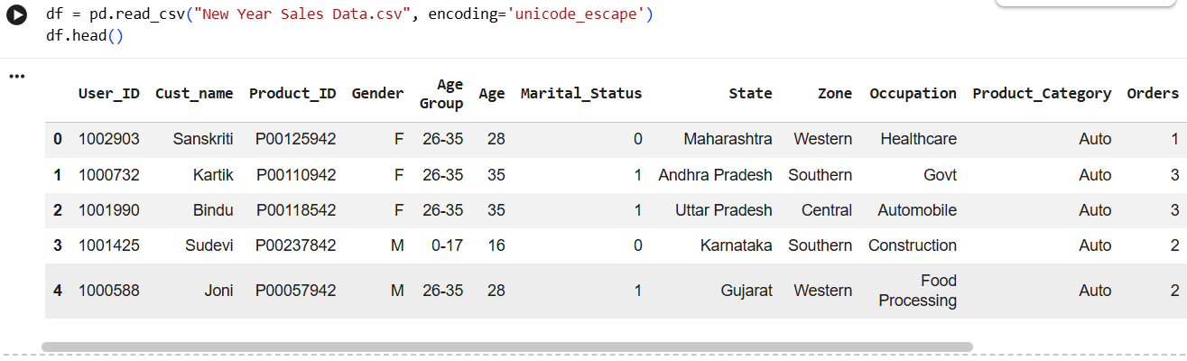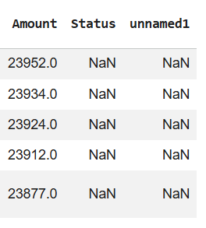
4. Data Cleaning
The following preprocessing steps were performed:
- Checked for missing values.
- Removed unnecessary columns:
  - Status
  - unnamed1
- Removed rows with missing Amount values.
- Converted the Amount column from float to integer datatype.
- Verified data types and dataset structure.
Final Dataset Size: 11,239 rows × 13 columns.
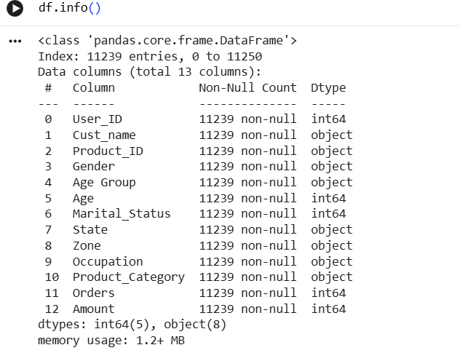
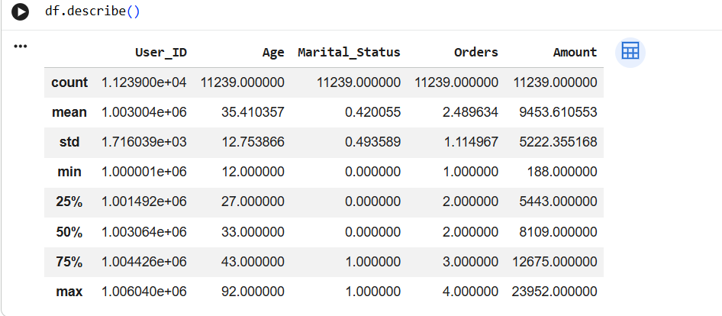
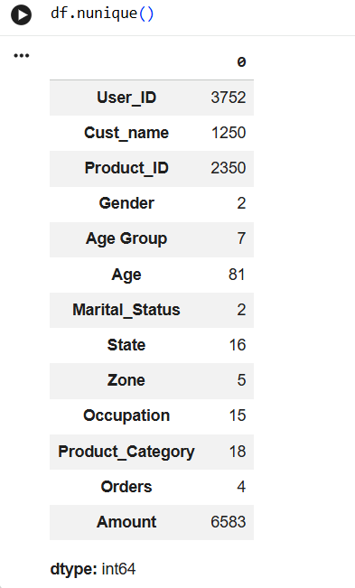
5. Exploratory Data Analysis
5.1 Gender Analysis
Findings:
- Female Customers: 7,832
- Male Customers: 3,407
Revenue Contribution:
- Female: ₹74,335,853
- Male: ₹31,913,276
Insight:
Female customers contribute significantly more revenue and represent the largest customer segment.
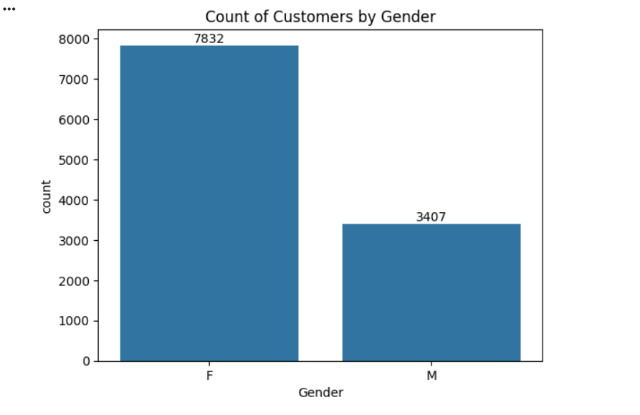
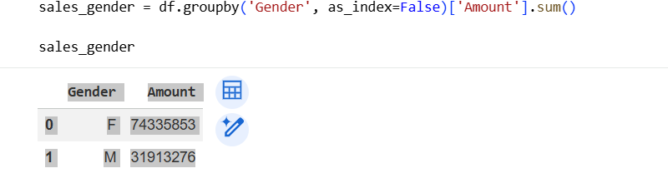
5.2 Age Group Analysis
Highest Revenue Generating Age Groups:
Age Group | Revenue
26-35 | ₹42,613,442
36-45 | ₹22,144,994
18-25 | ₹17,240,732
Insight:
Customers aged 26–35 years generate the highest revenue and form the largest customer group.
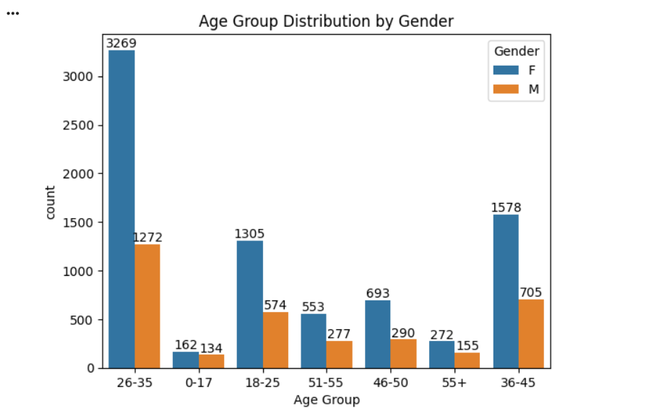
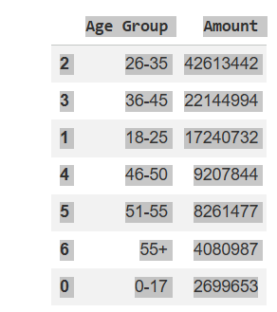

5.3 State Analysis
Top Revenue Generating States:
State | Revenue
Uttar Pradesh | ₹19,374,968
Maharashtra | ₹14,427,543
Karnataka | ₹13,523,540
Insight:
Uttar Pradesh, Maharashtra, and Karnataka are the strongest sales markets.

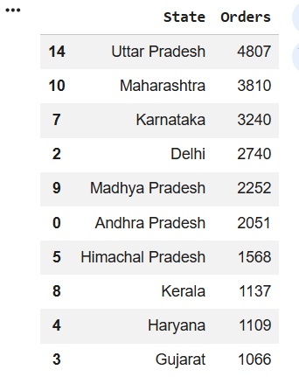 | 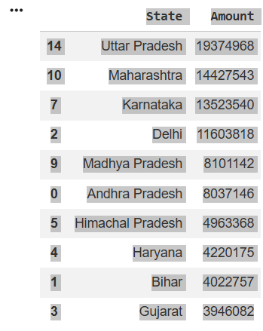

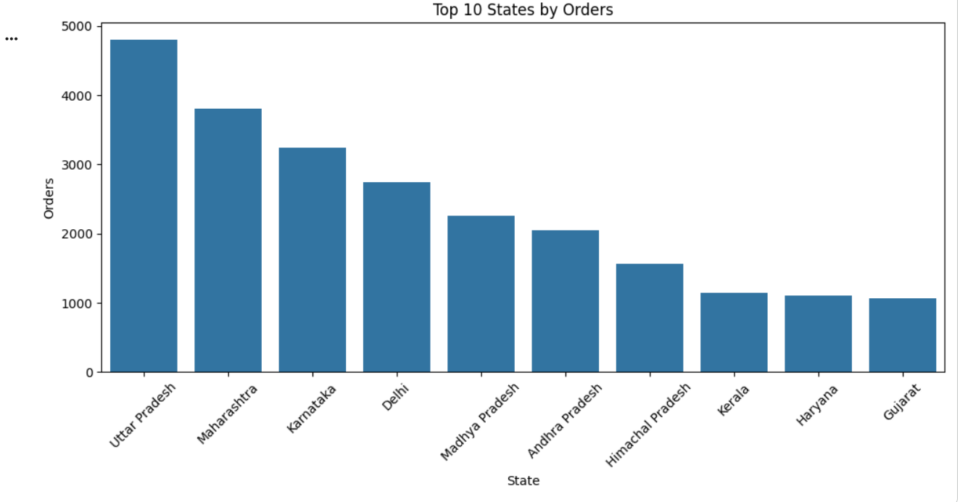

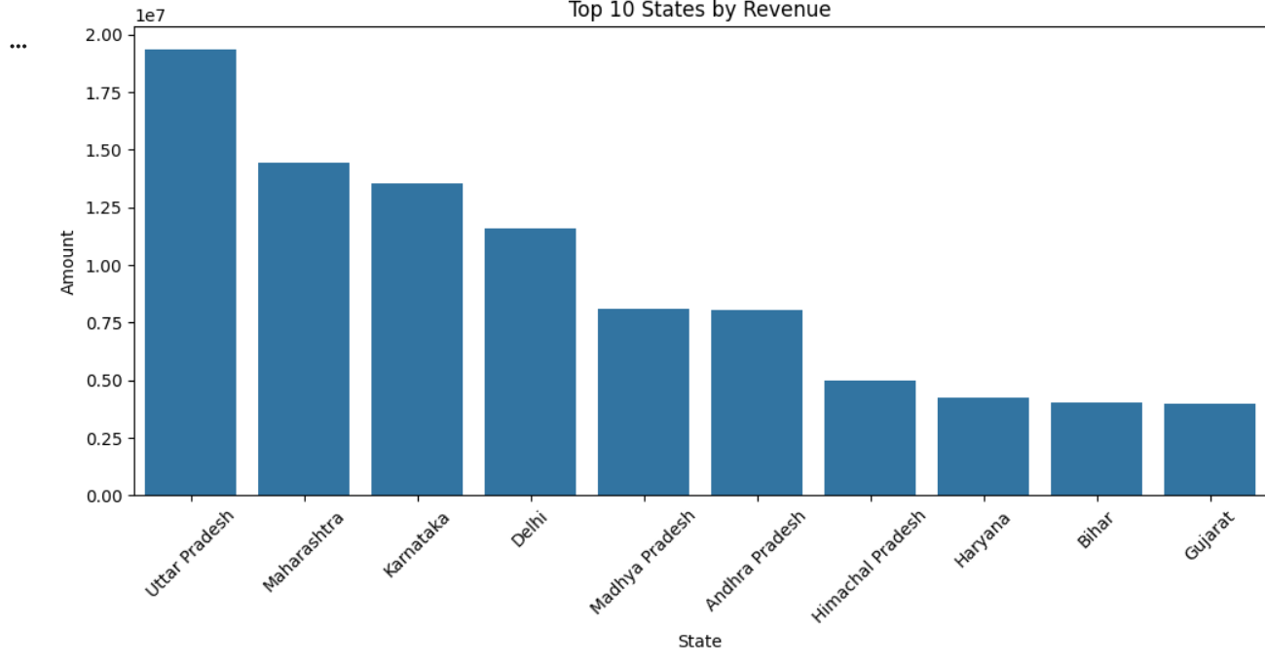
5.4 Marital Status Analysis
Customer Count:
- Unmarried: 6,518
- Married: 4,721
Revenue:
- Unmarried Customers: ₹62,125,384
- Married Customers: ₹44,123,745
Insight:
Unmarried customers contribute higher overall revenue, while female customers dominate spending in both groups.
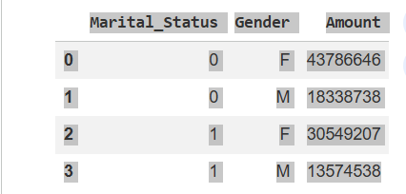
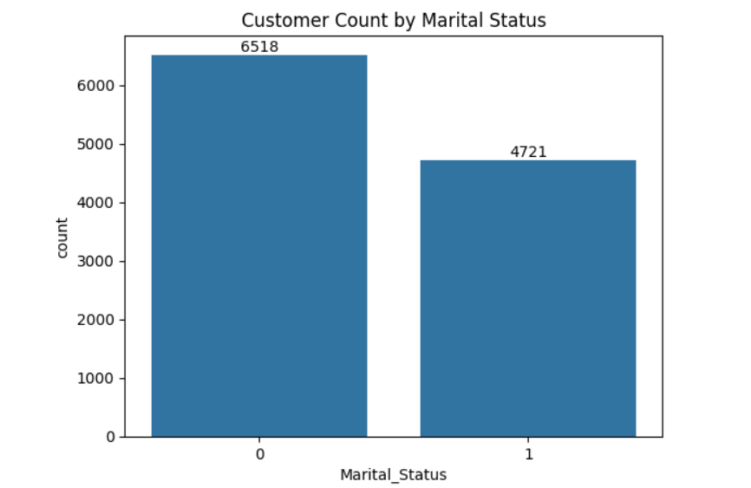
5.5 Occupation Analysis
Top Occupations by Revenue:
- IT Sector – ₹14,755,079
- Healthcare – ₹13,034,586
- Aviation – ₹12,602,298
- Banking – ₹10,770,610
Insight:
Professionals from IT, Healthcare, and Aviation sectors contribute the highest revenue. 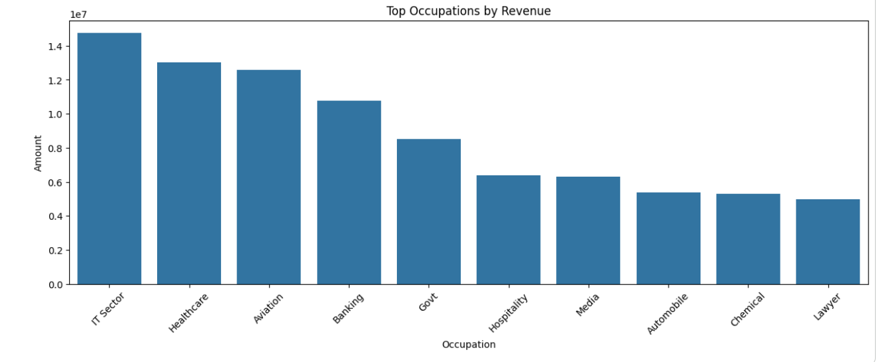
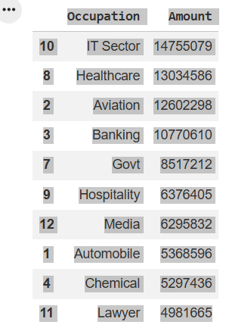
5.6 Product Category Analysis
Top Product Categories by Revenue:
- Food – ₹33,933,883
- Clothing & Apparel – ₹16,495,019
- Electronics & Gadgets – ₹15,643,846
- Footwear & Shoes – ₹15,575,209
Insight:
Food is the most profitable product category, followed by Clothing & Apparel and Electronics & Gadgets.
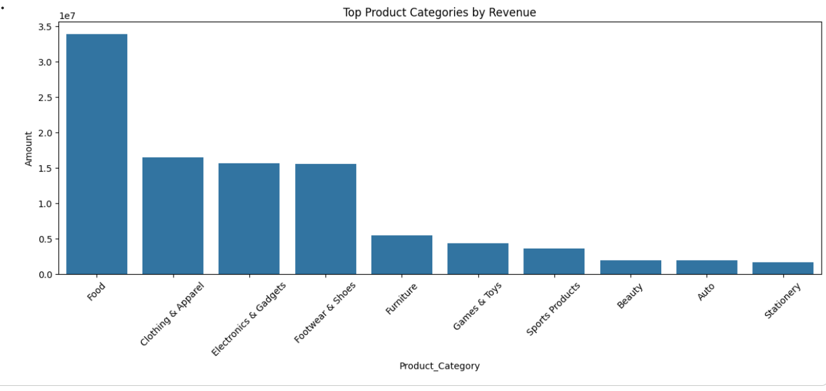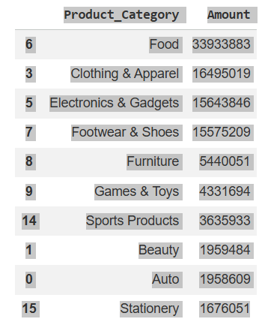

6. Conclusion
The analysis revealed that female customers aged 26–35 years are the most valuable customer segment. Uttar Pradesh, Maharashtra, and Karnataka generate the highest sales and revenue. Customers working in IT, Healthcare, and Aviation occupations contribute significantly to sales. Food, Clothing & Apparel, Electronics & Gadgets, and Footwear & Shoes are the leading product categories.
Customer Profile
The typical high-value customer is:
- Female
- Aged 26–35 years
- Located in Uttar Pradesh, Maharashtra, or Karnataka
- Working in IT, Healthcare, or Aviation
- Frequently purchases Food, Clothing, Electronics, and Footwear products
These insights can help businesses improve marketing strategies, customer targeting, and inventory planning to maximize future sales.

